# Code:

import pandas as pd

import numpy as np

from sklearn.datasets import fetch_openml

from sklearn.preprocessing import LabelEncoder,OneHotEncoder

#Load the dataset

data=fetch_openml('titanic',version=1,as_frame=True)

print(data)

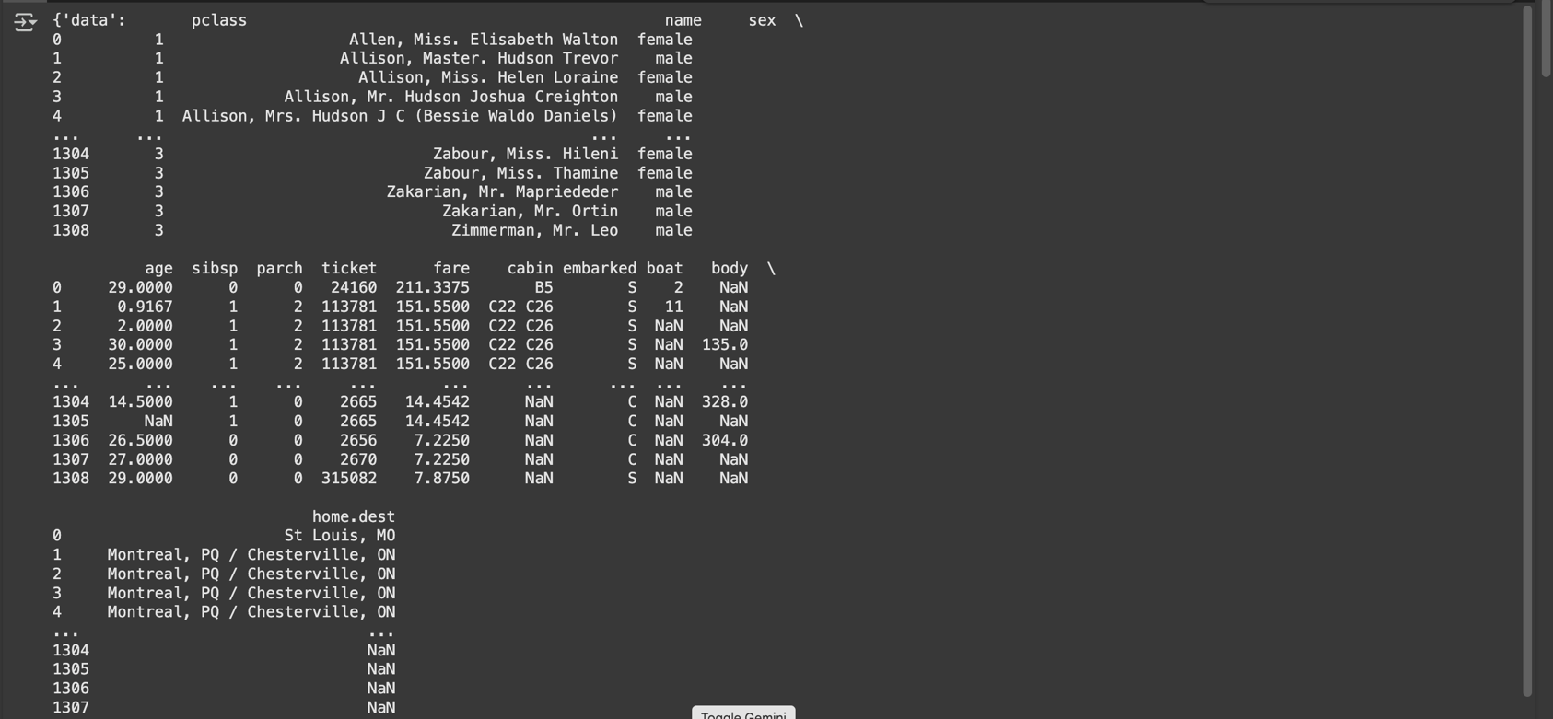

data['feature_names']

data_f=data.frame.copy()

#Dropping the empty values

data=data_f[['age','sex','fare','embarked','pclass','survived']].dropna()

set(list(data['embarked']))

#Lable Encoding

le=LabelEncoder()

data['embarked_le']=le.fit_transform(data['embarked'])

data.columns

data['embarked_le']

#One-Hot Encoder

ohe=OneHotEncoder()

# df_ohe=pd.get_dummies(data['sex'])

df_ohe=pd.get_dummies(data,columns=['sex'])

df_ohe

#Loadnthe dataset of diabetes

from sklearn.datasets import load_diabetes

data=load_diabetes(as_frame=True)

data=data.frame

print(data)

data.describe()

import seaborn as sns

import matplotlib.pyplot as plt

#Get coorelation in-between the features

corr=data.corr()

plt.figure(figsize=(10,8))

sns.heatmap(corr,annot=True)

plt.show()

#Feature Importance

from sklearn.tree import DecisionTreeRegressor

from sklearn.model_selection import train_test_split

data.columns

X_train,X_test,y_train,y_test=train_test_split(data.drop('target',axis=1),data['target'],test_size=0.2,random_state=42)

tree=DecisionTreeRegressor(max_depth=3)

tree.fit(X_train,y_train)

importance=pd.Series(tree.feature_importances_,index=X_train.columns)

importance